1. 填空题

1：假设

String s1 = "Welcome to Java";

String s2 = s1;

String s3 = new String("Welcome to Java");

那么下面表达式的结果是什么？

(1) s1 == s2 __________True ________________

(2) s1 == s3 __________False ________________

(3) s1.equals(s2) __________True _________________

(4) s2.equals(s3) __________True _________________

(5) s1.compareTo(s2); __________0_____________________

(6) s2.compareTo(s3); __________0_____________________

(7) s1.charAt(0); __________W_____________________

(8) s1.indexOf('j'); __________-1____________________

(9) s1.indexOf("to"); __________8_____________________

(10) s1.lastIndexOf("o",15) ________ 9_____________________

(11) s1.substring(3, 11); _________come to________________

(12) s1.endsWith("Java") ______True___________________

(13) s1.startsWith("wel"); _________False__________________

(14) " We come ".trim(); _________We come________________

(15) s1.toUpperCase(); _________WELCOME TO JAVA________

(16) s1.replace('o', 'T'); _________WelcTme tT Java____________

2．如果

StringBuffer s1 = new StringBuffer("Java");

StringBuffer s2 = new StringBuffer("HTML");

假设下列每个语句是独立的，每条语句结束后，写出相应结果

(1) s1.append(" is fun"); s1为__Java is fun____

(2) s1.append(s2); s1为___JavaHTML__________

(3) s1.insert(2, "is fun"); s1为___Jais funva________

(4) s1.insert(1,s2); s1为___JHTMLava__________

(5) char c = s1.charAt(2); c为____v__________________

(6) int i = s1.length(); i为____4__________________

(7) s1.deleteCharAt(3); s1为___Jav__________________

(8) s1.delete(1,3); s1为___Ja__________________

(9) s1.reverse(); s1为___avaJ_______________

(10) s1.replace(1,3, "Computer"); s1为__JComputera__________

(11) String s3 = s1.substring(1,3);

s3为_________av____________，s1为_______Java______________

(12) String s4 = s1.substring(2);

S4为_________va______________，s1为_____Java_______________

3. 假设StringBuffer s = new StringBuffer("Welcome to JAVA");

将s的内容清空的语句是___s = new StringBuffer(); 或s.setLength(0); 或s.delete(0, s.length());__________________。

4.如果

String s1 = "Welcome";  
String s2 = new String("Welcome");  
String s3 = s2.intern();  
String s4 = "Wel" + "come";  
String s5 = "Wel";  
String s6 = "come";  
String s7 = s5 + s6;  
String s8 = "Wel" + new String("come");

那么下面表达式的结果为：

（1）s1 == s2 ___False____

（2）s1 == s3 ___True_____

（3）s1 == s4 ___True_____

（4）s1 == s7 ___False___

（5）s1 == s8 ___False__

（6）s1.equals(s2) ___True_________

（7）s1.equals(s3) ___True_________

（8）s1.equals(s4) ___True_________

（9）s1.equals(s7) ___True_________

（10）s1.equals(s8) ___True_________

二、单项选择题

1．可以获取字符串s的最后一个字符的表达式是___C_____。

（A）s.length()

（B）s[s.length() - 1]

（C）s.charAt(s.length() - 1)

（D）charAt(s, length(s))

2. 下面程序

class C {

public static void main(String[] args) {

String s = “null”;

if(s == null)

System.out.print(“a”);

else if(s.length() == 0)

System.out.print(“b”);

else

System.out.print(“c”);

}

}

的输出为____C____。

（A）a （B）b

（C）c （D）null

3. 下面的程序

class C {

public static void main(String[] args) {

String s = “Welcome to ”;

concat(s);

System.out.print(s);

}

public static void concat(String s) {

s += “Java”;

}

}

的输出为___A_____。

（A）Welcome to （B）Welcome to Java

（C）编译错误 （D）运行时异常

三、编程题

1：编写程序，从控制台或对话框任意输入一个英文字符串，统计字符串中每个英文字母出现的次数并输出到控制台（大小写不敏感）。

import java.util.Scanner;

public class countChar {

public static void main(String[] args) {

Scanner sc = new Scanner(System.in);

int[] charCNT = new int[26];

System.out.println("input a string:");

String str = sc.nextLine();

str = str.trim().toLowerCase();

int len = str.length();

for(int i = 0; i < len; i++) {

char c = str.charAt(i);

charCNT[c - 'a']++;

}

for(int i = 0; i < charCNT.length; i++) {

if(charCNT[i] != 0) {

System.out.println((char)(i + 'a') + ": " + charCNT[i]);

}

}

}

}

运行测试：

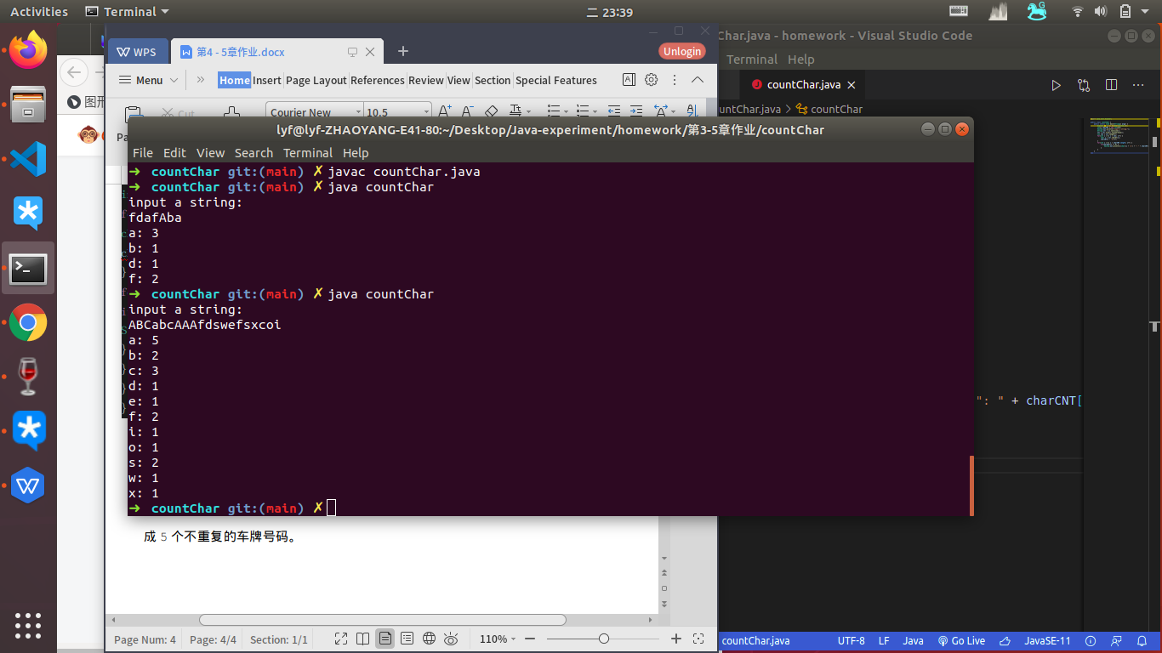

2：假设一个车牌号码由三个大写字母和后面的四个数字组成。编写一个程序. 随机生

成5个不重复的车牌号码。

import java.util.HashMap;

import java.util.Iterator;

import java.util.Map;

public class generateNumber {

public static void main(String[] args) {

Map<String, Boolean> strBoMap = new HashMap<String, Boolean>();

String[] res = new String[5];

for (int i = 0; i < 5; i++) {

res[i] = "";

String temp = generateCard();

while (strBoMap.containsKey(temp) == true) {

temp = generateCard();

}

strBoMap.put(temp, true);

res[i] += temp;

}

for(String s:res){

System.out.println(s);

}

}

public static String generateCard() {

String res = "";

for (int i = 0; i < 3; i++) {

res += String.valueOf((char) ('A' + (int) (Math.random() * 26)));

}

for (int i = 0; i < 4; i++) {

res += String.valueOf((int) (Math.random() * 10));

}

return res;

}

}

运行测试：

